SUMMER HOLIDAY
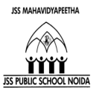
HOME WORK
Class – II
Dear students!
Summer holidays are approaching and holidays are supposed to be a break from studies but don’t forget to revise all the concepts done regularly. So, kids enjoy your holidays with some fun filled activities. Gear up and utilize your time in the best possible manner. Let’s cheer for the 3R’s – Rejuvenation, Relaxation and Rebonding!

English
1. Read a new story. Draw your favourite character from it on an A-4 sized pastel sheet.
2. Read English newspaper every day. Try to grasp new words and build your vocabulary.
3. Complete pages 1 to 25 in English Cursive Stroke Book.

हिंदी
1.फूलों पर एक कविता लिखें और चित्र चिपकाए I
2.हिंदी सुलेख के 15 पृष्ठ करे I
3. अपठित गद्यांश

Math
1.Make a beautiful and colourful ‘Snake and Ladder’ game on A-3 sheet.
2. Write number and number names from (1-100) in thin separate thin notebook.
3. Revision sheet

EVS
- Make a collage on different people who help us in daily life. (A-3 size sheet)
- Make beautiful and colourful flash cards on types of plants or animals.
3. Revision worksheet

COMPUTER
Draw a keyboard (All keys) on A3 size chart paper.

ART & CRAFT 2018-19
II-A:-
- Do Practice drawing and coloring everyday and make any one painting on A-4 Size sheet.
- Watch ‘Art Attack’ and ‘MAD’ on TV every day and make one painting and one craft object from it.
- Make a greeting card using pistachio cover.
II-B:-
- Do Practice drawing and coloring everyday and make any one painting on A-4 Size sheet.
- Watch ‘Art Attack’ and ‘MAD’ on TV every day and make one painting and one craft object from it.
- Make a PHOTO FRAME using ice-cream sticks and clay.
II-C:-
- Do Practice drawing and coloring everyday and make any one painting on A-4 Size sheet.
- Watch ‘Art Attack’ and ‘MAD’ on TV every day and make one painting and one craft object from it.
- Make a Book Mark using old Marriage Card.
II-D:-
- Do Practice drawing and coloring everyday and make any one painting on A-4Size sheet.
- Watch ‘Art Attack’ and ‘MAD’ on TV every day and make one painting and one craft object from it.
- Make a FLOWER GARDEN using pencil shavings.

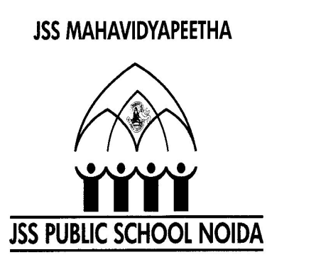JSS PUBLIC SCHOOL, NOIDA
MATHS REVISION WORKSHEET
CLASS - II
L- 2, ADDITION

NAME : _______________ ROLL NO-________ SECTION _______ DATE _________

- Find the sum:-

- T O 2) T O 3) T O

3 7 8 9 2 8

+ 4 3 + 7 + 5 2
_______ __________ _________

_______ __________ _________

4) T O 5) T O 6) T O
1 5 7 6 4 8
+ 2 7 + 2 7 + 5 9
___________ ___________ ___________
___________ ___________ ___________

7) T O 8) T O 9) T O
4 3 6 9 5 7
5 7 2 7 3 8
+ 1 6 + 2 3 + 1 5
____________ _____________ ____________
____________ _____________ ____________

- Solve the following word problems:-

- There are 55 red apples and 34 green apples on a tree. How many apples are there in all?
Sol:- _____________________________________________________________________
______________________________________________________________________
_____________________________________________________________________
_____________________________________________________________________
_____________________________________________________________________

- There were 36 big fish abd 54 small fish in a river. How many fishes were there altogether ?

Sol:- ____________________________________________________________________
____________________________________________________________________
____________________________________________________________________
____________________________________________________________________
____________________________________________________________________
____________________________________________________________________

- There are 21 apples, 28 bananas and 36 oranges. How many fruits are there in all?
Sol:- ___________________________________________________________________
__________________________________________________________________
___________________________________________________________________
____________________________________________________________________
____________________________________________________________________
____________________________________________________________________

JSS PUBLIC SCHOOL, NOIDA
EVS REVISION WORKSHEET
CLASS - II

NAME : _______________ ROLL NO-________ SECTION _______ DATE _________
- Answer the following questions:-

- What is a nuclear family?
Ans _______________________________________________________
_______________________________________________________

- Who are called cousins?
Ans ________________________________________________________
________________________________________________________

- What is a joint family ?
Ans __________________________________________________________
__________________________________________________________
__________________________________________________________

- Name any five people who help us in our daily lives.
Ans a) _____________ b) ______________ c) ______

d) _____________ e) _______________
5) What does each of the following do?
Ans a) Nurse :- _________________________________________
b) Cobbler :- ________________________________________
c) Milkman : - _______________________________________
B) Fill in the blanks:-
1. A _______________ sells fruits and vegetables.
2. A _______________ builds our home.
3. An architect _________ buildings.
4. A _____________ grows crops for us.
5. Large family is also called ____________________.

C. Answer in one word only:-
1. Who repairs electrical things? _________________________
2. Who looks after us when we are sick? _________________________
3. Who makes things out of wood? _________________________
4. Who teaches us in school? _________________________
5. Who brings milk for us? _________________________
6. Who looks after our safety? _________________________

D. Write whether you are living in joint family or nuclear family? Draw or paste a picture of your family in the space provided.
Ans: - ____________________________________________________

