**JSS PUBLIC SCHOOL, NOIDA**

SESSION(2018-19)

**HOLIDAY FUN**

**CLASS-1**



**Summer brings us the nice warm sun**

**For swimming, fishing and lots of fun**

**For finding seashells in the sand**

**For sunbathing to get a tan**

**To do all these things and more**

**At the beach and at the seashore**

Dear Children,

Summer Vacation is synonymous with fun and frolic, going for picnics, playing for long hours, exploring new places and much more……But, dear children, there is a lot more you can do to make your vacation more interesting and meaningful. We have planned some interesting activities for you. So get ready to enjoy your summer vacation!

Here is an “ACTIVITY TREASURE BOX” for you .All the best and have FUN!

When the school reopens bring back your TREASURE,

To go through it will be our PLEASURE

* Complete all the activities during the vacation.
* All the work should be handwritten.
* Original drawings / illustrations and creative use of material will be appreciated.
* Parents are requested to just guide the children to complete the task on their own.

**ENGLISH**

1. Read and enjoy the following stories:

* The Gingerbread Man
* Snow White and the Seven Dwarfs
* Cinderella
* Hansel and Gretel
* The Elves and the Shoemaker
* Little Red Riding Hood
* Rapunzel

Or any other interesting story

Learn and narrate any one story in the class using props (face masks, hand puppets, flash cards)



2. **VOCABULARY MOBILE(HANGING)-**

Cut a big circle on an A-3 size sheet. Write a big word on it

eg HAPPINESS and illustrate it. Now make as many small words as you can from the letters of the big word.eg. PAN, SPIN, PINE etc and write each word on small circles or decorative cut outs of any shape from another A-4 size sheet. Attach these cut outs to the big circle using satin ribbons .You can use your creativity to make the vocabulary hanging attractive. Make 2 hangings based on any two new words which you have learnt from the above mentioned stories.

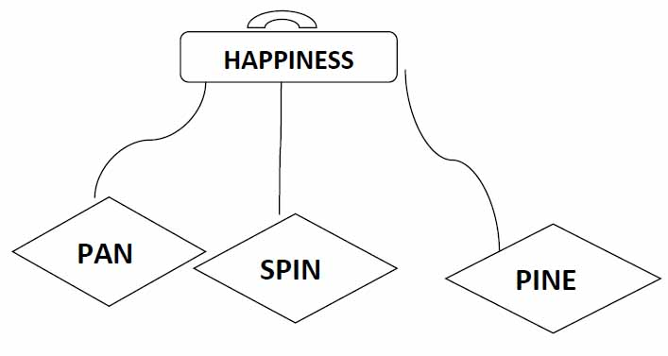

3. Daddy’s Day Out : Father’s Day is observed on the third Sunday of June. It honours all fathers, grandfathers and father figures for their contribution. So on this Father’s Day—

* Pamper your Dad

* Make him feel special in every way

* Surprise him by giving him a card and a gift.

* Collect the photographs of “How you love your father” make a collage on A4 sheet and prepare five lines on Father’s day.

* Prepare a mouth-watering recipe which might become his all time favourite. An example of one such recipe is given below.

RECIPE TIME—“Banana Split Ice Cream” with your mother’s help.

**Ingredients:**

1 Scoop of Vanilla ice cream

1 Scoop of strawberry ice cream

1 Ripe banana

Some nuts

Chocolate Syrup

**Method:**

Wear your chef cap and apron. Cut a banana in half lengthwise and lay it in the dish. Put scoops of vanilla and strawberry ice cream served in a row between the split banana .Garnish it with crushed nuts and chocolate syrup. Enjoy your banana treat.

Don’t forget to click pictures. Paste them on an A-4 size sheet.

4. Practice cursive handwriting daily in the Cursive Writing book ( pg no.7 to 30)

5. Worksheet

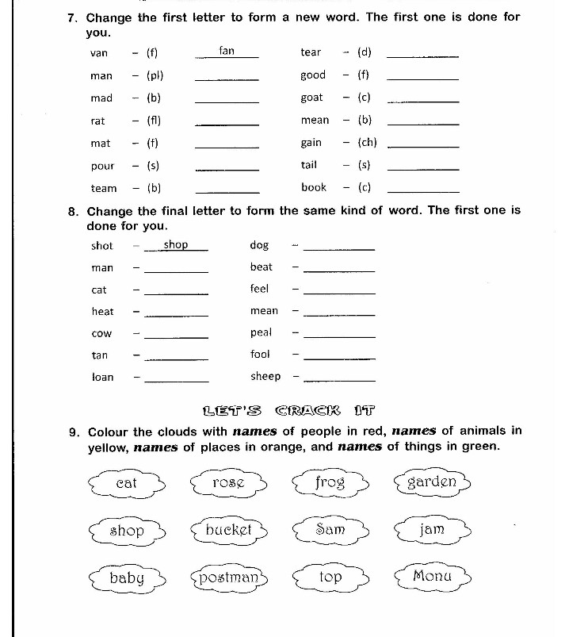

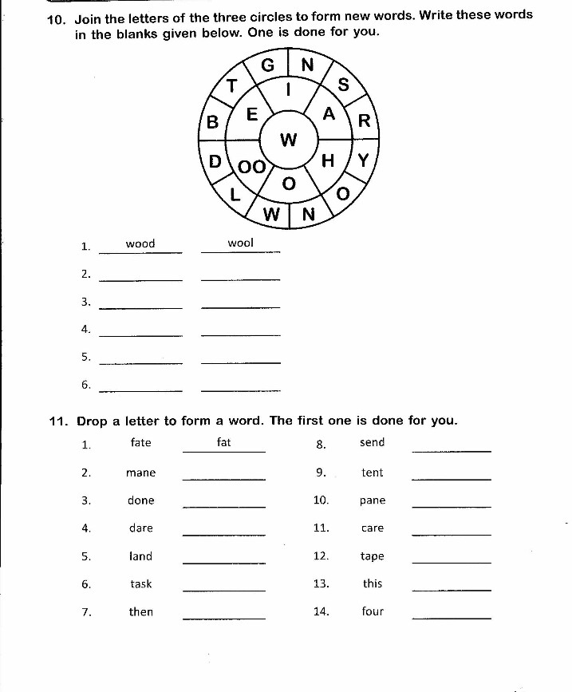

**MATHS**

|  |
| --- |
| 1. Present the information given below beautifully on an A-3 sheet. Complete the information about yourself using numbers only.     * Letters in my name - * My age - * My class - * My height - * Members in my family- * Number of teeth I have- * My shoe size - * My father’s phone number - * My mother’s phone number - |

2. Prepare a wind chime showing the tables 2&3.

3. Draw or paste picture of your favourite eatables (any 5) and write the shape of each. Example

Pizza – Circle, Sandwich – Triangle

4. Worksheets

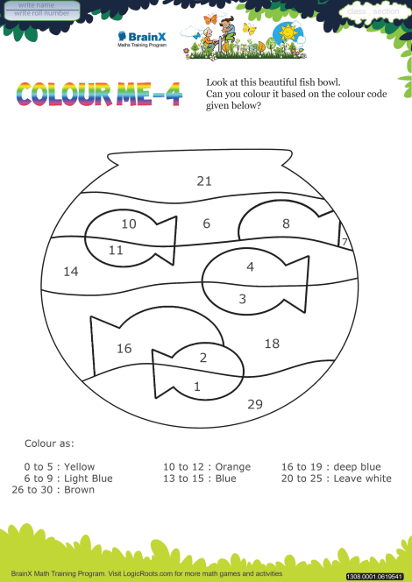

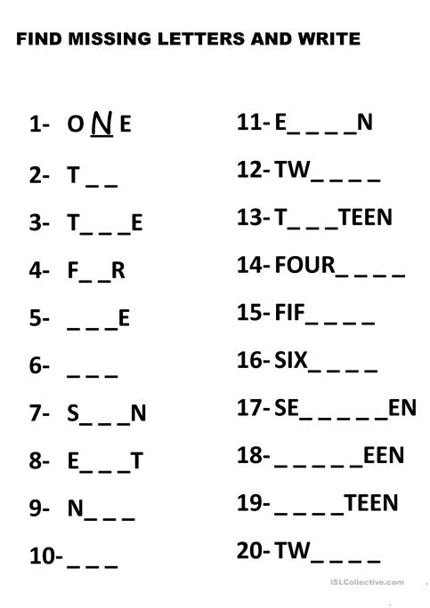

**E.V.S**

1. Have a close look at your surroundings while you are in the park. Observe how beautiful the flowers and plants are, how people are having fun and all the activities that you do to make your day a memorable one. On an A-3 size sheet, using eco friendly and child friendly materials such as dried leaves, match sticks, pencil shavings,cotton etc create a scene of the park you visited.

2. Make a Family tree in your scrap book.

3. Visit any 2 of the following places with your family:

 Zoo

 Traffic Training Park

 Rail / Doll Museum

 Children’s Park

 Bank/Post-Office

 Any historical monument

Draw and paste picture on A4 size sheet (any one)of your visiting place and Share the experience of that place with your teacher and friends.

4. Worksheets

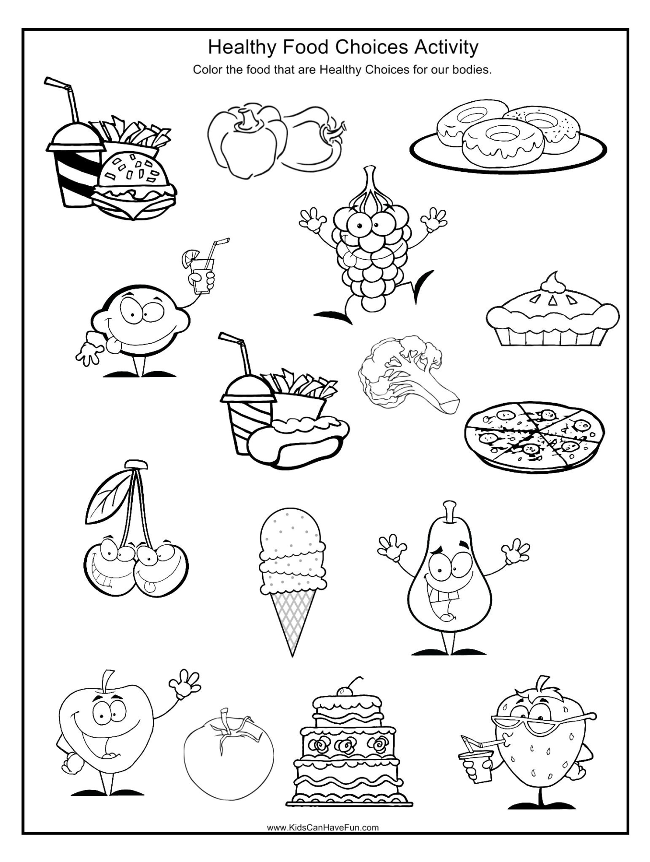

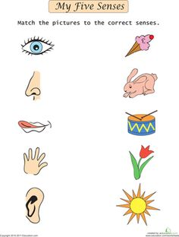

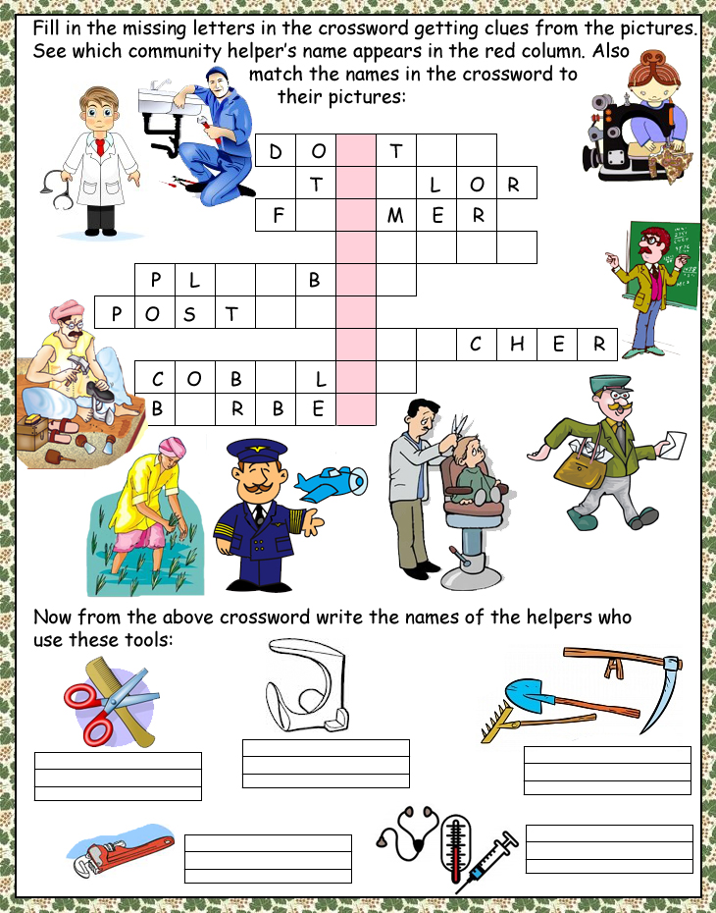

HINDI

१. कक्षा प्रतियोगिता के लिए पर्यावरण पर कविता तैयार करे

२. शब्दअन्ताक्षरी – शब्दों की रेलगाड़ी बनाए (on A-3 sheet)

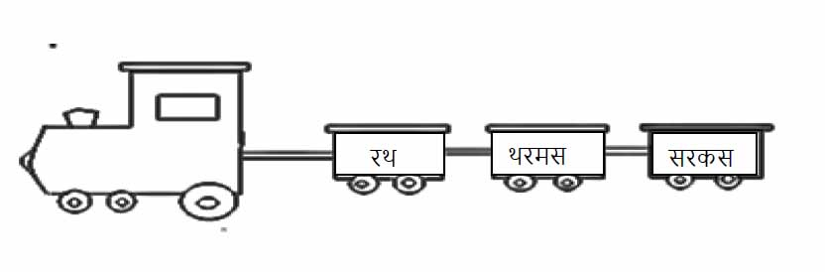

३. किसी एक विषय पर दस पक्तिया याद करो -

मेरीमाँ , मेरादेश , मेरामित्र , पेड़ - पौधे

**COMPUTERS**

* **Draw and colour parts of computer on A3 sheet.**

**ART and CRAFT**

|  |
| --- |
|  |

* **For Class I-A:-**

1. **Do practice of drawing and coloring everyday and make any one painting on A 4 Size sheet.**
2. **Watch ‘Art Attack’ and ‘MAD’ on TV every day and make one painting and one craft object from it.**
3. **Make a Photo Frame using Ice-cream sticks.**

**ForClassI-B:-**

1. **Do practice of drawing and coloring everyday and make any one painting on A 4 Size sheet.**
2. **Watch ‘Art Attack’ and ‘MAD’ on TV every day and make one painting and one craft object from it.**
3. **Make a Bird Nest using cotton and ice cream cup.**

**ForClassI-C:-**

1. **Do practice of drawing and coloring everyday and make any one painting on A 4 Size sheet.**
2. **Watch ‘Art Attack’ and ‘MAD’ on TV every day and make one painting and one craft object from it.**
3. **Make a Book Mark using old Marriage Card.**

**ForClassI-D:-**

1. **Do practice of drawing and coloring everyday and make any one painting on A 4 Size sheet.**
2. **Watch ‘Art Attack’ and ‘MAD’ on TV every day and make one painting and one craft object from it.**
3. **Make a bird nest using cotton and ice-cream cup.**

**Note:**

* **Date of Oratory holiday assignment will be intimated after the summer vacation.**
* **Please label all the holiday homework and send them in a labeled (name and class/section) in a paper bag.**